Na obrázku je vidět vizuální signalizace vstupních/výstupních signálů žlutými šipkami.
Tato signalizace je O.K. Alert vst/výst.signálů, který by měl být součástí indikátoru mi však nefinguje. Poradíte, pomůžete?

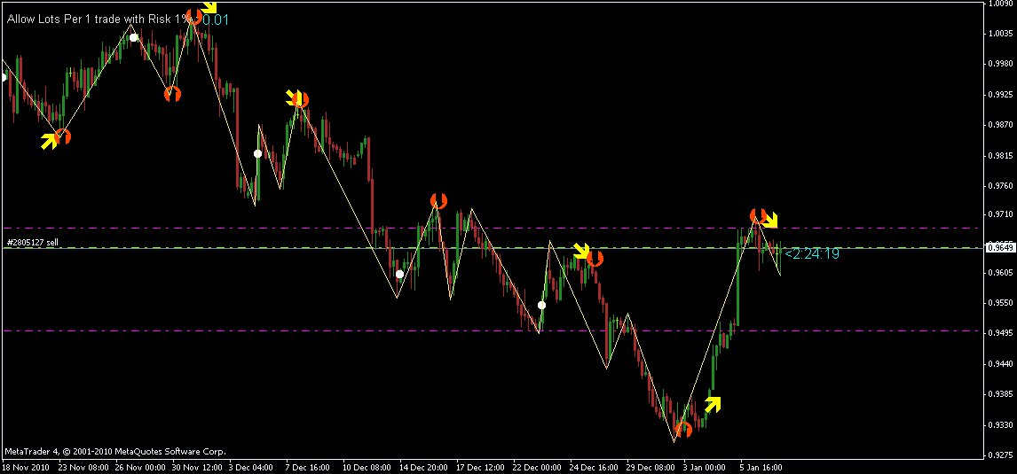

//+--------------------------------------------------------------------------+
//| 3 MA Cross w_Alert v2.mq4 |
//| Copyright © 2005, Jason Robinson (jnrtrading) |
//| http://www.jnrtading.co.uk |
//| 3 ma conversion and Alert , David Honeywell , transport.david@gmail.com |
//| http://finance.groups.yahoo.com/group/MetaTrader_Experts_and_Indicators/ |
//+--------------------------------------------------------------------------+
/*
+-------------------------------------------------------------------------------+
| Allows you to enter 3 ma periods and it will then show you and alert you at |
| which point the 2 faster ma's "OPEN" are both above or below the Slowest ma . |
+-------------------------------------------------------------------------------+
*/
#property copyright "Copyright © 2005, Jason Robinson (jnrtrading)"
#property link "http://www.jnrtrading.co.uk"
//----
#property indicator_chart_window
#property indicator_buffers 2
#property indicator_color1 Red
#property indicator_color2 Green
//----
double CrossUp[];
double CrossDown[];
double prevtime;
double Range, AvgRange;
double fasterMAnow, fasterMAprevious, fasterMAafter;
double mediumMAnow, mediumMAprevious, mediumMAafter;
double slowerMAnow, slowerMAprevious, slowerMAafter;
//----
extern int FasterMA = 5;
extern int FasterShift = -5;
extern int FasterMode = 1; // 0 = sma, 1 = ema, 2 = smma, 3 = lwma
extern int MediumMA = 20;
extern int MediumShift = -5;
extern int MediumMode = 1; // 0 = sma, 1 = ema, 2 = smma, 3 = lwma
extern int SlowerMA = 34;
extern int SlowerShift = 0;
extern int SlowerMode = 1; // 0 = sma, 1 = ema, 2 = smma, 3 = lwma
extern int SoundAlert = 1; // 0 = disabled
//+------------------------------------------------------------------+
//| Custom indicator initialization function |
//+------------------------------------------------------------------+
int init()
{
//---- indicators
SetIndexStyle(0, DRAW_ARROW, EMPTY);
SetIndexArrow(0, 236);
SetIndexBuffer(0, CrossUp);
SetIndexStyle(1, DRAW_ARROW, EMPTY);
SetIndexArrow(1, 238);
SetIndexBuffer(1, CrossDown);
//----
return(0);
}
//+------------------------------------------------------------------+
//| Custom indicator deinitialization function |
//+------------------------------------------------------------------+
int deinit()
{
//----
//----
return(0);
}
//+------------------------------------------------------------------+
//| Custom indicator iteration function |
//+------------------------------------------------------------------+
int start()
{
int limit, i, counter;
int counted_bars=IndicatorCounted();
//---- check for possible errors
if(counted_bars<0) return(-1);
//---- last counted bar will be recounted
if(counted_bars>0) counted_bars--;
//----
limit=Bars-counted_bars;
//----
for(i = 0; i <= limit; i++)
{
counter=i;
Range=0;
AvgRange=0;
for (counter=i ;counter<=i+9;counter++)
{
AvgRange=AvgRange+MathAbs(High[counter]-Low[counter]);
}
Range=AvgRange/10;
//----
fasterMAnow = iMA(NULL, 0, FasterMA, FasterShift, FasterMode, PRICE_CLOSE, i+1);
fasterMAprevious = iMA(NULL, 0, FasterMA, FasterShift, FasterMode, PRICE_CLOSE, i+2);
fasterMAafter = iMA(NULL, 0, FasterMA, FasterShift, FasterMode, PRICE_CLOSE, i-1);
//----
mediumMAnow = iMA(NULL, 0, MediumMA, MediumShift, MediumMode, PRICE_CLOSE, i+1);
mediumMAprevious = iMA(NULL, 0, MediumMA, MediumShift, MediumMode, PRICE_CLOSE, i+2);
mediumMAafter = iMA(NULL, 0, MediumMA, MediumShift, MediumMode, PRICE_CLOSE, i-1);
//----
slowerMAnow = iMA(NULL, 0, SlowerMA, SlowerShift, SlowerMode, PRICE_CLOSE, i+1);
slowerMAprevious = iMA(NULL, 0, SlowerMA, SlowerShift, SlowerMode, PRICE_CLOSE, i+2);
slowerMAafter = iMA(NULL, 0, SlowerMA, SlowerShift, SlowerMode, PRICE_CLOSE, i-1);
//----
if ((fasterMAnow > slowerMAnow &&
fasterMAprevious <= slowerMAprevious &&
fasterMAafter > slowerMAafter &&
mediumMAnow > slowerMAnow )
||
(fasterMAnow > slowerMAnow &&
mediumMAnow > slowerMAnow &&
mediumMAprevious <= slowerMAprevious &&
mediumMAafter > slowerMAafter ))
{
CrossUp[i] = Low[i] - Range*0.75;
}
if ((fasterMAnow < slowerMAnow &&
fasterMAprevious >= slowerMAprevious &&
fasterMAafter < slowerMAafter &&
mediumMAnow < slowerMAnow )
||
(fasterMAnow < slowerMAnow &&
mediumMAnow < slowerMAnow &&
mediumMAprevious >= slowerMAprevious &&
mediumMAafter < slowerMAafter ))
{
CrossDown[i] = High[i] + Range*0.75;
}
}
if ((CrossUp[0] > 2000) && (CrossDown[0] > 2000)) { prevtime = 0; }
if ((CrossUp[0] == Low[0] - Range*0.75) && (prevtime == Time[0]) && (SoundAlert == 0))
{
prevtime = Time[0];
Alert(Symbol(),"3 MA Cross Up");
}
if ((CrossDown[0] == High[0] + Range*0.75) && (prevtime == Time[0]) && (SoundAlert == 0))
{
prevtime = Time[0];
Alert(Symbol(),"3 MA Cross Down");
}
//Comment(" CrossUp[0] ",CrossUp[0]," , CrossDown[0] ",CrossDown[0]," , prevtime ",prevtime);
//Comment("");
return(0);
}
//-------------------------------------------------------+

